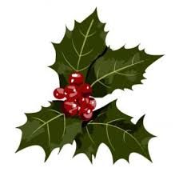Holiday Shopping List
Who? | What Do They Like? | Gift Ideas | Where? | How Much?

